**Project Design Phase-II**

**Data Flow Diagram & User Stories**

|  |  |
| --- | --- |
| Date | 15 April 2025 |
| Team ID | SWTID1743689010 |
| Project Name | Book Store |
| Maximum Marks | 4 Marks |

**Data Flow Diagrams:**

A Data Flow Diagram (DFD) is a traditional visual representation of the information flows within a system. A neat and clear DFD can depict the right amount of the system requirement graphically. It shows how data enters and leaves the system, what changes the information, and where data is stored.

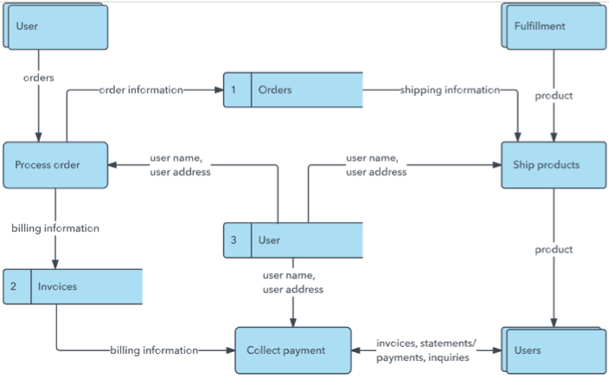

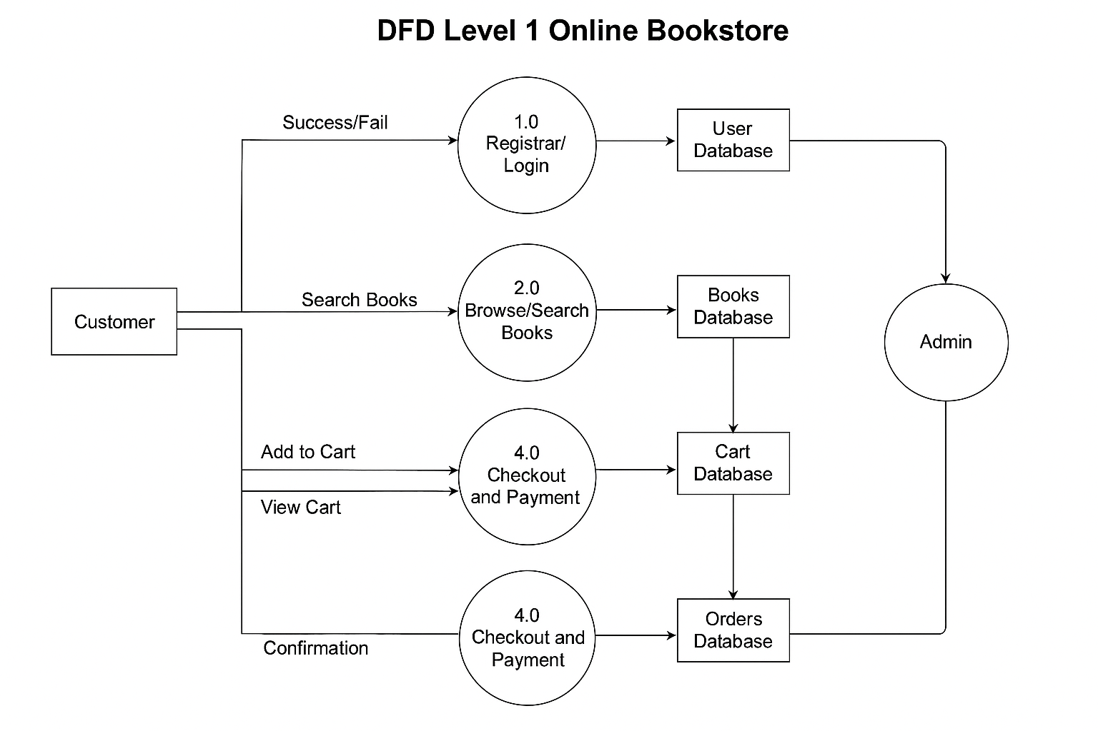

**Figure: DFD Level 1 – Online Bookstore System**

**User Stories**

Use the below template to list all the user stories for the product.

|  |  |  |  |  |  |  |
| --- | --- | --- | --- | --- | --- | --- |
| **User Type** | **Functional Requirement (Epic)** | **User Story Number** | **User Story / Task** | **Acceptance Criteria** | **Priority** | **Release** |
| Customer (Mobile user) | Registration | USN-1 | As a user, I can register using email/password | I can access my account/dashboard | High | Sprint-1 |
|  |  | USN-2 | As a user, I receive a confirmation email after registration | I receive a confirmation email | High | Sprint-1 |
|  |  | USN-3 | As a user, I can register with Facebook | Facebook login works correctly | Low | Sprint-2 |
|  |  | USN-4 | As a user, I can register with Gmail | Gmail login works correctly | Medium | Sprint-1 |
|  | Login | USN-5 | As a user, I can log in with email/password | I’m redirected to the dashboard after login | High | Sprint-1 |
|  | Browse/Search Books | USN-6 | As a user, I can search for books by title/author/category | Search returns relevant results | High | Sprint-1 |
|  | Add to Cart | USN-7 | As a user, I can add books to my cart | Book appears in cart | High | Sprint-2 |
|  | Checkout | USN-8 | As a user, I can checkout and pay using a payment gateway | Payment is processed and order confirmation received | High | Sprint-2 |
|  | Order History | USN-9 | As a user, I can view my order history | I can see all previous orders | Medium | Sprint-3 |
| Customer (Web user) | Same as above | USN-10 to USN-15 | Same as mobile user functionality | Works on responsive web interface | Medium | Sprint-3 |
| Customer Care Exec | Support Tickets | USN-16 | As support staff, I can view customer issues and respond | Issues are tracked and replies are sent | Medium | Sprint-3 |
|  | Order Tracking | USN-17 | I can track customer orders and update delivery status | Status updates reflected on customer side | High | Sprint-3 |
| Administrator | Manage Inventory | USN-18 | As admin, I can add/edit/delete book listings | Changes are saved in the DB | High | Sprint-1 |
|  | User Management | USN-19 | As admin, I can view and manage user accounts | Users can be banned or granted privileges | Medium | Sprint-2 |
|  | Dashboard | USN-20 | As admin, I can view statistics like sales and active users | Admin sees graphs and tables | Medium | Sprint-3 |

Prepared by: [Your Name(s)]

Team ID: [Your Team ID]

Course: Software Engineering

Instructor: [Your Teacher's Name]

|  |
| --- |
| **User Type Functional Requirement (Epic) User Story Number User Story / Task Acceptance Criteria Priority Release**  Customer (Mobile user) Registration USN-1 As a user, I can register using email/password I can access my account/dashboard High Sprint-1  USN-2 As a user, I receive a confirmation email after registration I receive a confirmation email High Sprint-1  USN-3 As a user, I can register with Facebook Facebook login works correctly Low Sprint-2  USN-4 As a user, I can register with Gmail Gmail login works correctly Medium Sprint-1  Login USN-5 As a user, I can log in with email/password I’m redirected to the dashboard after login High Sprint-1  Browse/Search Books USN-6 As a user, I can search for books by title/author/category Search returns relevant results High Sprint-1  Add to Cart USN-7 As a user, I can add books to my cart Book appears in cart High Sprint-2  Checkout USN-8 As a user, I can checkout and pay using a payment gateway Payment is processed and order confirmation received High Sprint-2  Order History USN-9 As a user, I can view my order history I can see all previous orders Medium Sprint-3  Customer (Web user) Same as above USN-10 to USN-15 Same as mobile user functionality Works on responsive web interface Medium Sprint-3  Customer Care Exec Support Tickets USN-16 As support staff, I can view customer issues and respond Issues are tracked and replies are sent Medium Sprint-3  Order Tracking USN-17 I can track customer orders and update delivery status Status updates reflected on customer side High Sprint-3  Administrator Manage Inventory USN-18 As admin, I can add/edit/delete book listings Changes are saved in the DB High Sprint-1  User Management USN-19 As admin, I can view and manage user accounts Users can be banned or granted privileges Medium Sprint-2  Dashboard USN-20 As admin, I can view statistics like sales and active users Admin sees graphs and tables Medium Sprint-3 |

|  |  |  |  |  |  |  |
| --- | --- | --- | --- | --- | --- | --- |
| Customer (Web user) |  |  | As a user, I can add books to my cart | Book appears in cart |  |  |
| Customer Care Executive |  |  |  |  |  |  |
| Administrator |  |  |  |  |  |  |
|  |  |  |  |  |  |  |
|  |  |  |  |  |  |  |
|  |  |  |  |  |  |  |